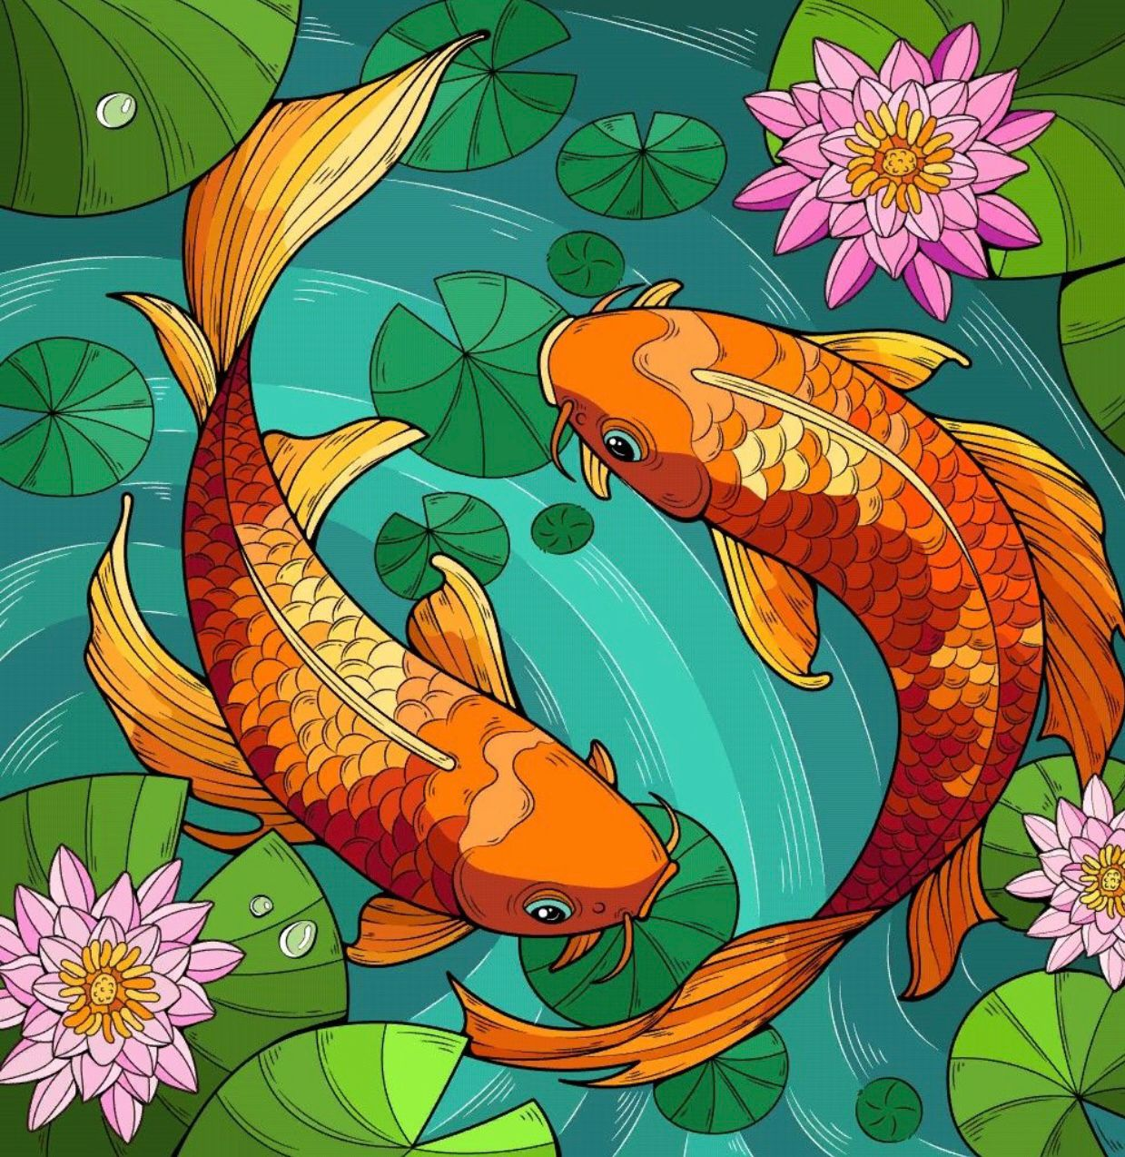

**Assignment 1**

**Marker color study**

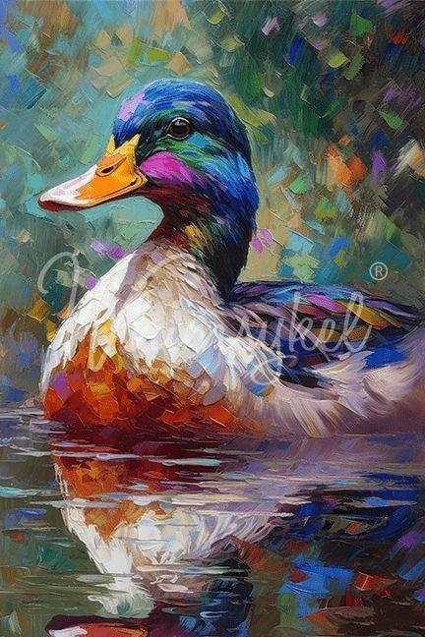

**Assignment 2**

**Pastel Study**

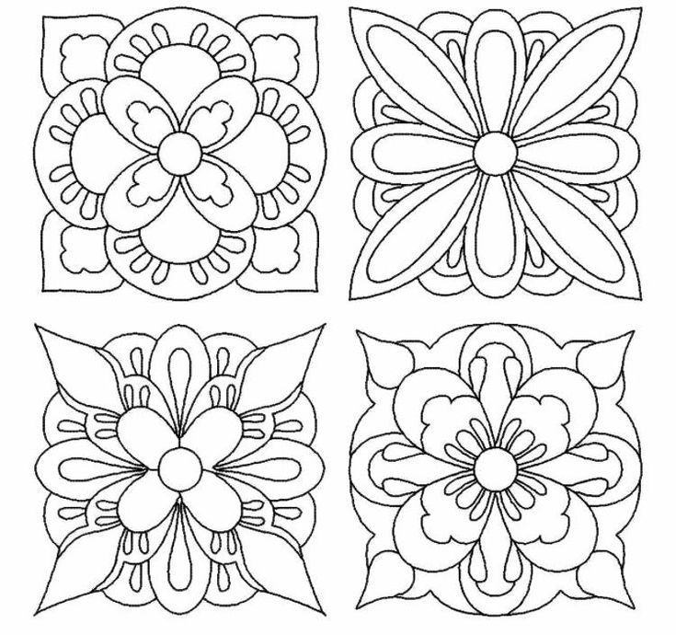

**Assignment 3**

**Tile Design**

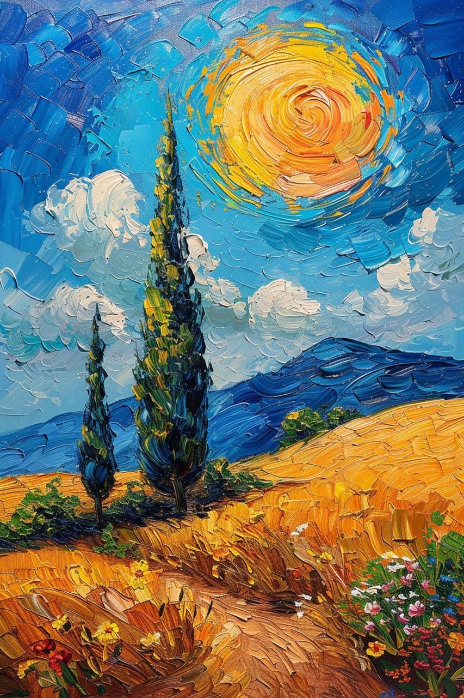

**Assignment 5**

**Painting**

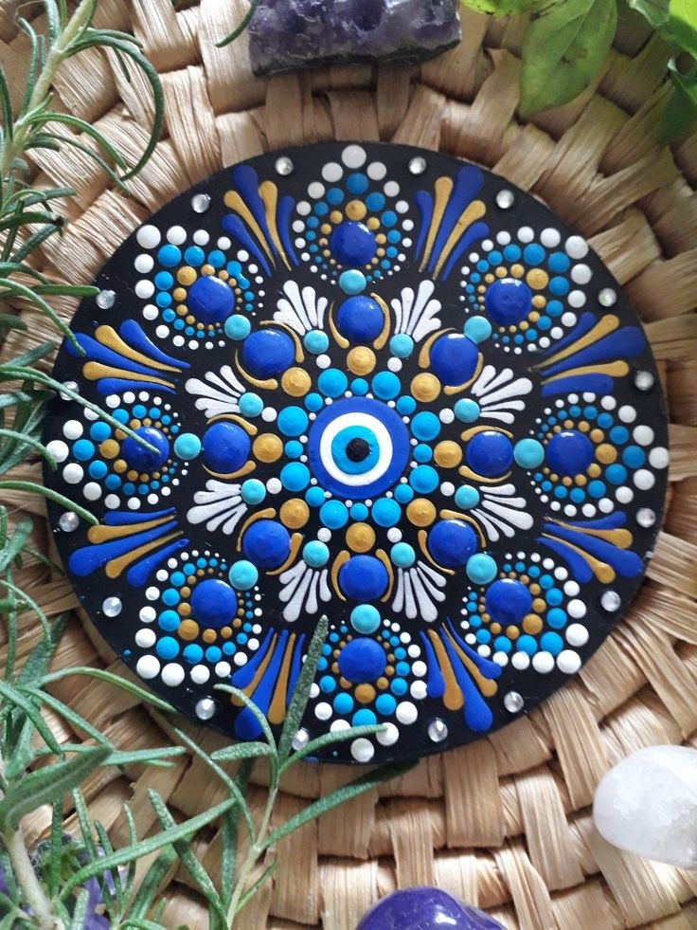

**Assignment 6**

**Mandala Art**